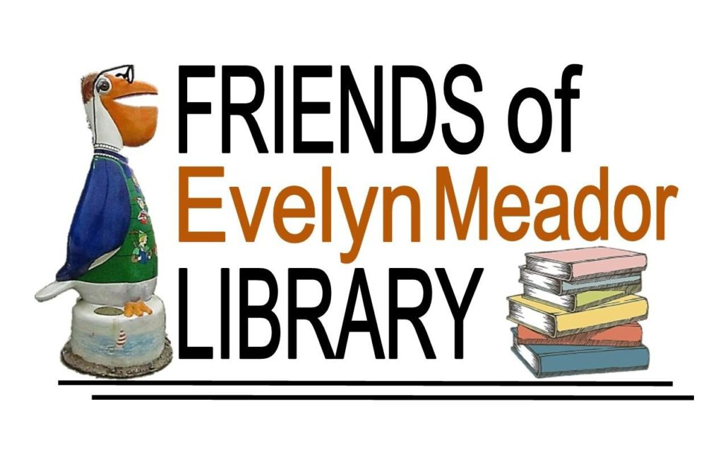
Web site: http://www.friendsofevelynmeador.org/
E-mail: info@friendsofevelynmeador.org
Annual Newsletter of the Friends of Evelyn Meador Library
January 2017 Edition
Dear Friends,
It is membership renewal time for the Friends of the Evelyn Meador Library. If you have already renewed, please accept our thanks. If you would like to renew or become a member, please return the enclosed membership form.
We hope you have been enjoying the Evelyn Meador Library and Friends Bookstore. We would like to share some of the activities and programs that the Friends supported in 2016.
Collection Development - $8,000 Staff Support - $3,000
Children’s Department - $7,000 Staff Development - $2,000
Adult Department - $1,500 Equipment/Furnishing - $3,000
Young Adult Program - $2,500 Special Events - $500
Here are the many wonderful programs that were delivered to the community in 2016:
Adult-114 Children-307 Teen-261 Computer-222 ESL/Literacy-659 Citizenship-16
The Friends depend largely on membership dues, book sales and financial donations. Here are a couple of convenient options to consider:
- Kroger Community Rewards Program - if you’re not already linked to an organization, please consider taking part in this program. Kroger will contribute to participating organizations based on their percentage of spending as it relates to the total spending of all participating Kroger Community Reward organizations. Here’s how to set it up:
  - Go to www.kroger.com/signin?redirectUrl=/account/communityrewards/enroll
  - Sign in with your Kroger account information or create a new account. A digital account is required to activate this feature.
  - Find your Organization – search for “FRIENDS OF THE EVELYN MEADOR LIBRARY # 80603”
  - Select and enroll. It’s that simple! Your enrollment in Community Rewards needs to be renewed each year.
  - REMEMBER, purchases will not count towards rewards until after you have registered your Kroger Plus card and linked it to the Friends.

- Amazon Smiles - register with Amazon Smile and every time you make an eligible purchase, Amazon will donate 0.5% to the Friends of Evelyn Meador Library! It's easy to sign up, doesn't cost you anything, and will directly benefit our organization. Here’s how to set it up:
- Go to www.smile.amazon.com
- Sign in using your existing Amazon account or register for an account.
- Under “Pick your own charitable organization” search for “Friends of the Evelyn M Meador Community Library”.
- Click “Select” and you’re done! You should get an email confirming your Amazon Smile registration.

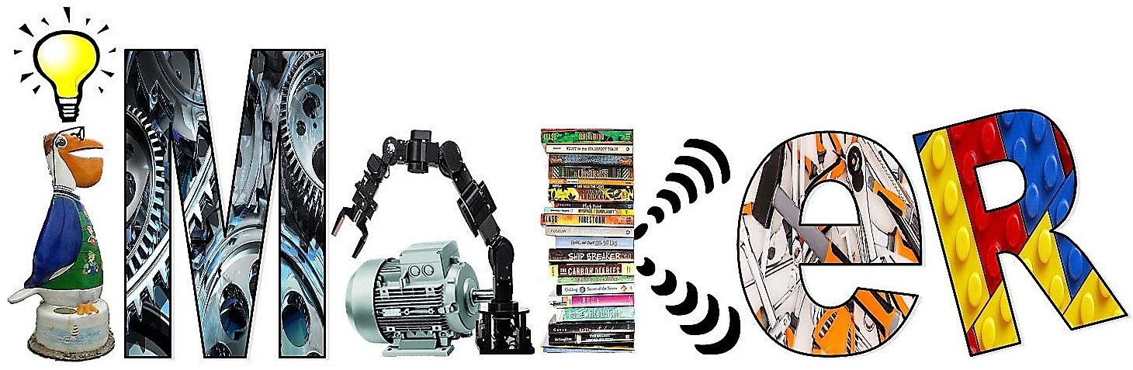

iMaker Makerspace Makes a Debut at Evelyn Meador!
Evelyn Meador Library's newly-opened iMaker makerspace is a community-operated workspace where people with common interests can meet, collaborate, and learn to create. The library’s makerspace is free to use and many maker programs and classes are being created to offer the public free of charge. Examples of classes to be offered include computer coding/programming and 3D modeling.
Makerspaces encourage STEAM values (i.e., Science, Technology, Engineering, Arts, and Math) and provide children, teenagers and adults the chance to apply what they learn.
Equipment inside the iMaker includes:
• Green Screen- Video production using Apple product
• 3D polyprinter
• Sewing/Quilting Machine
• Snap Circuits
• Soldering Kits
• Microphone Recording
• VHS to DVD converter
• Electronics and more

Please donate or sign up for membership today! The rewards are many. Seabrook is a vibrant community that thrives on programs that meet a variety of needs. We look forward to your support to help make 2017 an exciting year!
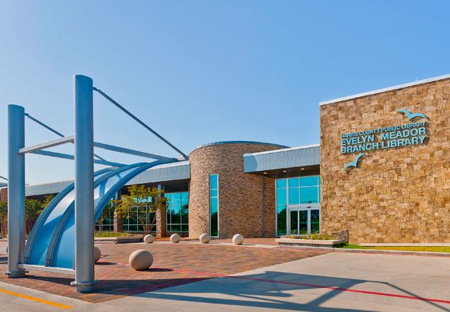
Evelyn Meador Library
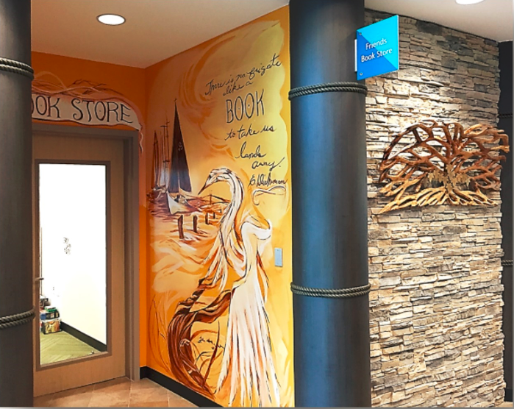
Friends Bookstore
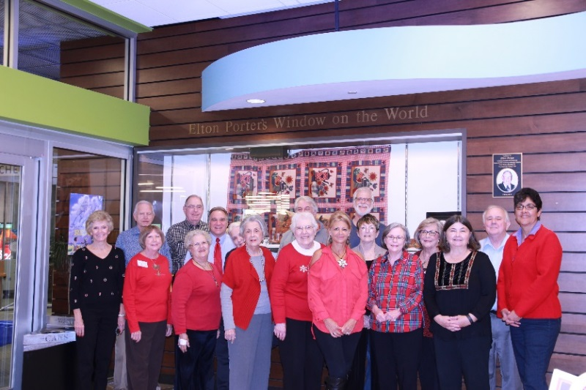
Friends of Evelyn Meador Board of Directors
Save The Dates!
Second Annual Library Beautification Event
(Outdoor facilities only)
When: Saturday, April 8, 2017
Where: Evelyn Meador Library

2017 Friends Annual Meeting
When: Tuesday, April 25, 2017 at 7:00 p.m.
Refreshments will be served at 6:30 p.m.
Where: Evelyn Meador Library, Large Meeting Room
Speaker to be announced!
Check friendsofevelynmeador.org for more details!
---------------------------------------------------------Cut here---------------------------------------------------------------

Mail with payment to: Friends of Evelyn Meador Library
PO Box 684, Seabrook, TX 77586

___ Individual $5.00 ___ Patron $50.00
___Family $10.00 ___ Sustaining $100.00

Name: __________________________________________________________________________________
Address: _______________________________________________________________________________
Phone: _________________________________________________________________________________
Email: __________________________________________________________________________________

