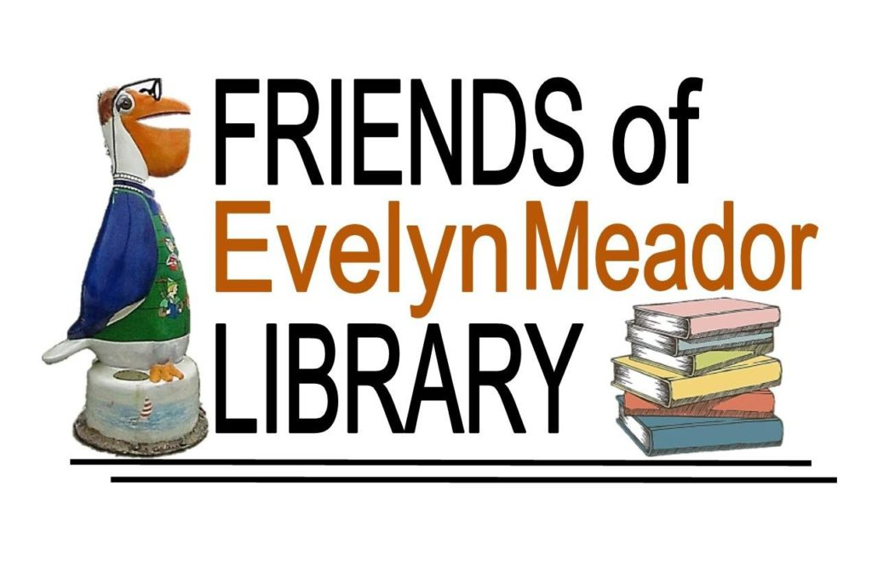
Web: http://www.friendsofevelynmeador.org
E-mail: info@friendsofevelynmeador.org
Annual Newsletter of the Friends of Evelyn Meador Library
January 2018 Edition
Dear Friends,
Once again, it’s membership renewal time for the Friends of the Evelyn Meador Library! If you have already renewed, please accept our sincere thanks for your support. If you would like to renew or become a member, please return the enclosed membership form found at the end of this newsletter.
We hope you have been enjoying the beautiful Evelyn Meador Library and Friends Bookstore. Here are a few of the programs and events that the Friends supported in 2017:
- April – Library Beautification Day
- June - Summer Reading Program
- June - Evelyn Meador Library’s 29th Birthday Celebration
- December – Visit with Santa
- December – Volunteer Holiday Reception
In addition, the Friends provided funding to upgrade and improve the library; check out the new chairs in the periodicals reading area. They are very comfortable and come with built-in charging ports for customers’ electronic devices. In our Makerspace, we have a 3D Polyprinter, a Makerbot, an iPad/green screen for video production, and many other tools and toys for your enjoyment as you create. A laser engraver has been ordered. Please contact the library to find out how you can be approved to use these tools.
The Friends depend largely on membership dues, book sales and financial donations. Here are a couple of convenient options to consider:
- Kroger Community Rewards Program - if you’re not already linked to an organization, please consider taking part in this program. Kroger will contribute to participating organizations based on their percentage of spending as it relates to the total spending of all participating Kroger Community Reward organizations. Here’s how to set it up:
  - Go to www.kroger.com/signin?redirectUrl=/account/communityrewards/enroll
  - Sign in with your Kroger account information or create a new account. A digital account is required to activate this feature.
  - Find your Organization – search for “FRIENDS OF THE EVELYN MEADOR LIBRARY # 80603”
  - Select and enroll. It’s that simple! Your enrollment in Community Rewards needs to be renewed each year.
  - REMEMBER, purchases will not count towards rewards until after you have registered your Kroger Plus card and linked it to the Friends.

- Amazon Smiles - register with Amazon Smile and every time you make an eligible purchase, Amazon will donate 0.5% to the Friends of Evelyn Meador Library! It's easy to sign up, doesn't cost you anything, and will directly benefit our organization. Here’s how to set it up:
- Go to www.smile.amazon.com
- Sign in using your existing Amazon account or register for an account.
- Under “Pick your own charitable organization” search for “Friends of the Evelyn M Meador Community Library”.
- Click “Select” and you’re done! You should get an email confirming your Amazon Smile registration.

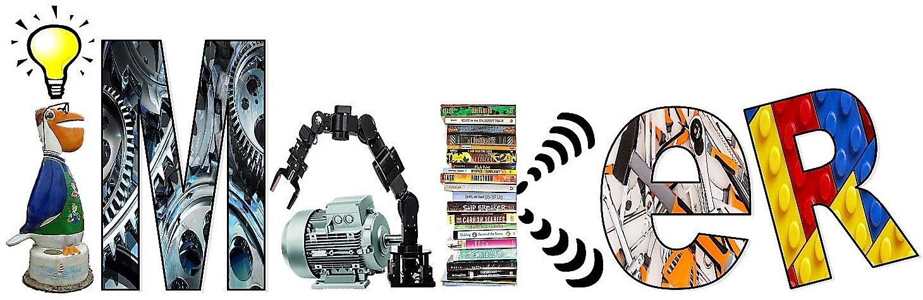

iMaker Makerspace Makes a Debut at Evelyn Meador!
Evelyn Meador Library's newly-opened iMaker makerspace is a community-operated workspace where people with common interests can meet, collaborate, and learn to create. The library’s makerspace is free to use and many maker programs and classes are being created to offer the public free of charge. Examples of classes to be offered include computer coding/programming and 3D modeling.
Makerspaces encourage STEAM values (i.e., Science, Technology, Engineering, Arts, and Math) and provide children, teenagers and adults the chance to apply what they learn.
Equipment inside the iMaker includes:
• Green Screen- Video production using Apple product
• 3D polyprinter
• Sewing/Quilting Machine
• Snap Circuits
• Soldering Kits
• Microphone Recording
• VHS to DVD converter
• Electronics and more

Please donate or sign up for membership today! The rewards are many. Seabrook is a vibrant community that thrives on programs that meet a variety of needs. We look forward to your support to help make 2018 an exciting year!
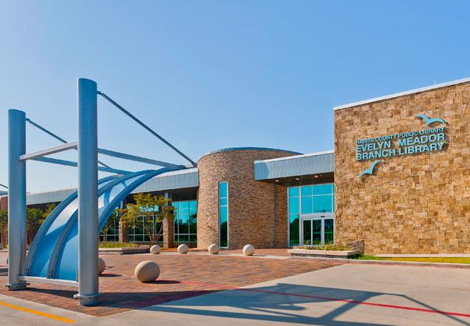
Evelyn Meador Library
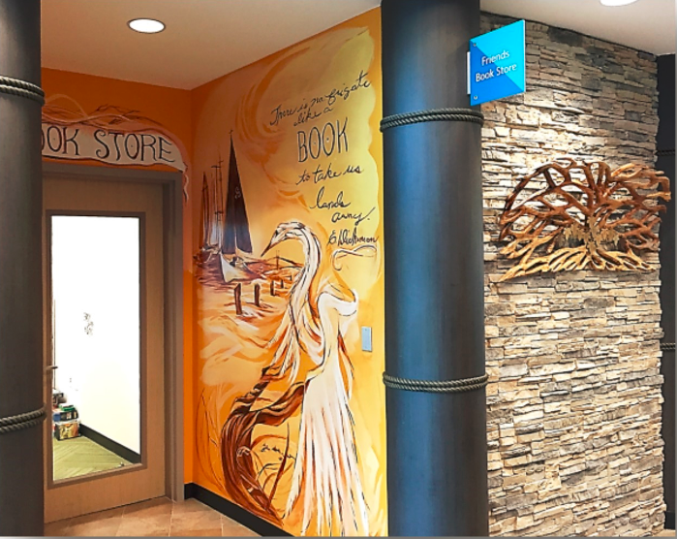
Friends Bookstore
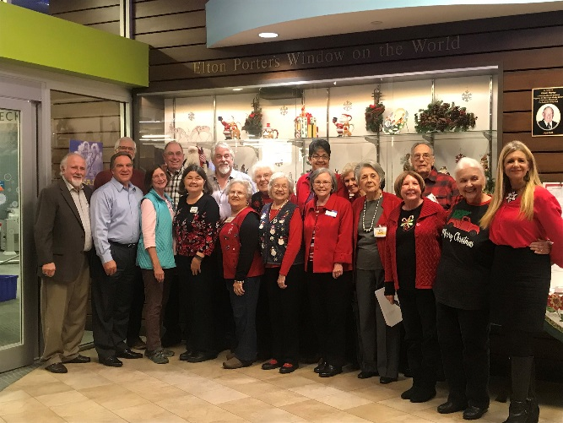
Friends of Evelyn Meador Board of Directors

Save The Dates!
3rd Annual Library Beautification Event
(Outdoor facilities only)
When: Saturday, March 24, 2018 from 10:30 am-12:00 pm
Where: Evelyn Meador Library

2017 Friends Annual Meeting
When: Tuesday, April 24, 2018 at 7:00 p.m.
Refreshments will be served at 6:30 p.m.
Where: Evelyn Meador Library, Large Meeting Room
Speaker to be announced!
Check friendsofevelynmeador.org for more details!
---------------------------------------------------------Cut here---------------------------------------------------------------

Mail with payment to: Friends of Evelyn Meador Library
PO Box 684, Seabrook, TX 77586

___ Individual $5.00 ___ Patron $50.00
___Family $10.00 ___ Sustaining $100.00

Name: __________________________________________________________________________________
Address: _______________________________________________________________________________
Phone: _________________________________________________________________________________
Email: __________________________________________________________________________________

