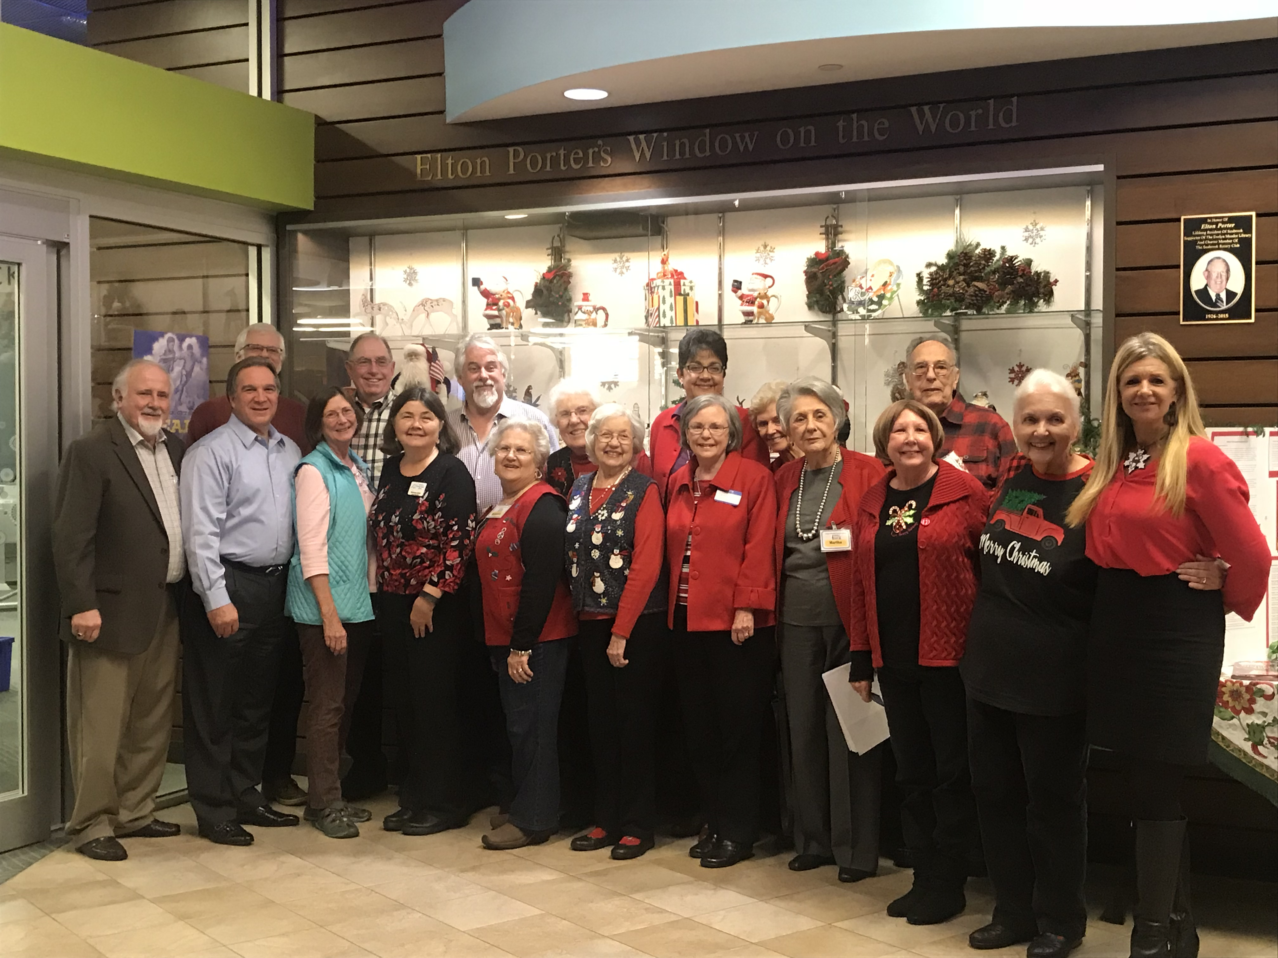
The Friends of Evelyn Meador Library
Invite You to Attend the 2018 Annual Meeting
On Tuesday, April 24th
In the Wallach Community Room

We are excited to present the following speakers this year:
- Seabrook Mayor Thom Kolupski
- Seabrook City Manager Gayle Cook
They will be providing an update on the Highway 146 Expansion Project
Refreshments will be served at 6:30 pm
Meeting starts at 7:00 pm
Everyone is Welcome!*
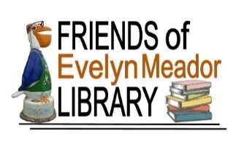
friendsofevelynmeador.org
*Come early – seating is limited
"Neither this business or organization nor this event is sponsored, endorsed or otherwise affiliated with the City of Seabrook”

