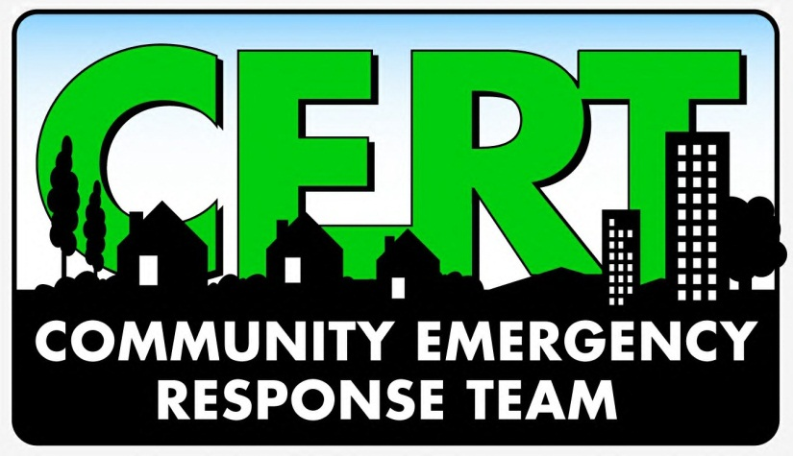
**FREE Training**
Tuesdays – September 11-October 30, 2018
6:30pm – 9:30pm
Seabrook Public Works Facility
1100 Red Bluff Road, Seabrook, TX 77586

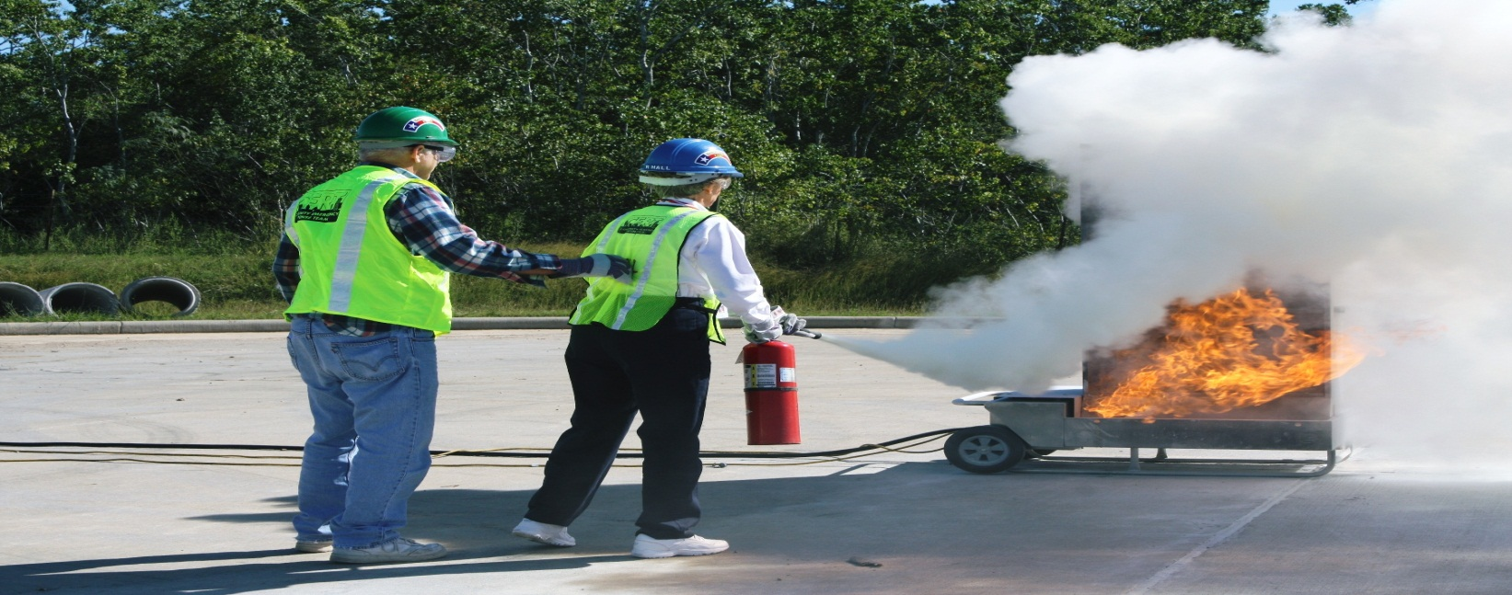

8 Week CERT Training Includes:

Disaster Preparedness | Fire Suppression
Medical Triage/Treatment | Light Search & Rescue
Disaster Psychology | CERT Organization
Terrorism Awareness | Course Review/Disaster Simulation

For Information and to pre-register, Contact BayCERT at
baycert@gmail.com

