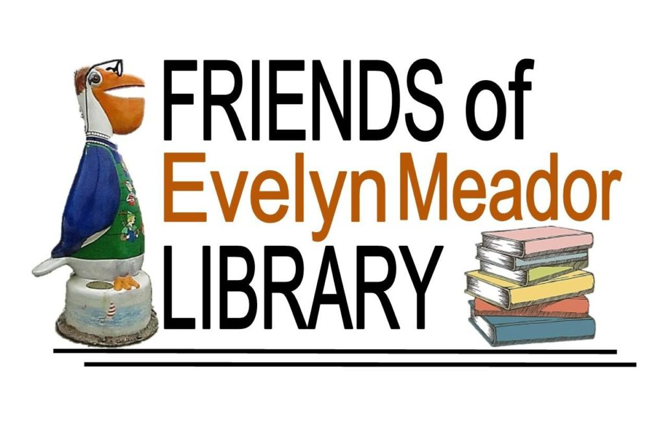
Web: friendsofevelynmeador.org
E-mail: info@friendsofevelynmeador.org
Friends of Evelyn Meador Library Annual Newsletter
January 2019 Edition
Dear Friends,
Once again, it’s membership renewal time for the Friends of the Evelyn Meador Library! If you have already renewed, please accept our sincere thanks for your support. If you would like to renew or become a member, please return the enclosed membership form found at the end of this newsletter.
We hope you have been enjoying the beautiful Evelyn Meador Library and Friends Bookstore! Here are a few of the programs and events that the Friends supported in 2018:
- April – 2nd Annual Library Beautification Day
- June - Summer Reading Program
- June - Evelyn Meador Library’s 30th Birthday Celebration
- December – Visit with Santa
- December – Volunteer Holiday Reception
Here are some impressive 2018 statistics:
- Adult Programs - 232
- Teen Programs - 204
- Children’s Programs -228
- ESL (English as a Second Language) Classes - 446
- Computer Classes – 157
- Citizenship Classes – 7
Total Class Offerings - 1274
The Friends depend largely on membership dues, book sales and financial donations. Here are a couple of convenient options to consider:
- Kroger Community Rewards Program - if you’re not already linked to an organization, please consider taking part in this program. Kroger will contribute to participating organizations based on their percentage of spending as it relates to the total spending of all participating Kroger Community Reward organizations. Here’s how to set it up:
  - Go to www.kroger.com/signin?redirectUrl=/account/communityrewards/enroll
  - Sign in with your Kroger account information or create a new account. A digital account is required to activate this feature.
  - Find your Organization – search for “FRIENDS OF THE EVELYN MEADOR LIBRARY # 80603”
  - Select and enroll. It’s that simple! Your enrollment in Community Rewards needs to be renewed each year.
  - REMEMBER, purchases will not count towards rewards until after you have registered your Kroger Plus card and linked it to the Friends.

- Amazon Smiles - register with Amazon Smile and every time you make an eligible purchase, Amazon will donate 0.5% to the Friends of Evelyn Meador Library! It's easy to sign up, doesn't cost you anything, and will directly benefit our organization. Here’s how to set it up:
- Go to www.smile.amazon.com
- Sign in using your existing Amazon account or register for an account.
- Under “Pick your own charitable organization” search for “Friends of the Evelyn M Meador Community Library”.
- Click “Select” and you’re done! You should get an email confirming your Amazon Smile registration.

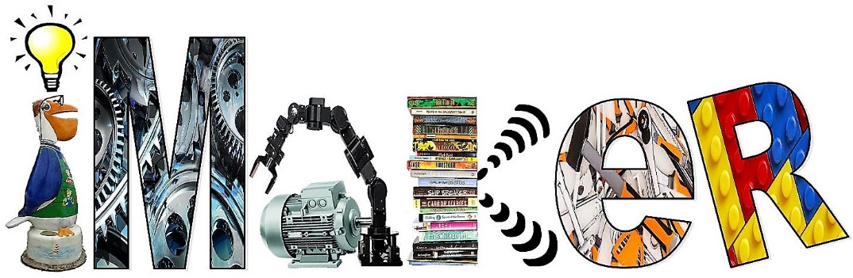
iMaker Space Continues to Shine!
The Evelyn Meador Library iMaker Space offers unique programs that empower and ignite the possibilities for all ages. It is “…a place where everyone has an opportunity to explore their own interests; learn to use tools and materials, both physical and virtual; and develop creative projects".
Maker Spaces encourage STEAM values (i.e., Science, Technology, Engineering, Arts, and Math) and provide children, teenagers and adults the chance to apply what they learn. The facility is free to use and many programs and classes are being planned in 2019.
Equipment inside the iMaker Space includes:
- Green Screen- Video production using Apple product
- 3D polyprinter
- Sewing/Quilting Machine
- Snap Circuits
- Soldering Kits
- Microphone Recording
- VHS to DVD converter
- Electronics and more
Other program areas of focus in 2019 include:
1. Outdoor Learning Center- This project is currently in the planning stages; we are looking for additional grants to help us move forward. It's a program that helps get kids fit and fight obesity.
2. Family Play Place- This is a grant based program in collaboration with the Barbara Bush Foundation.

Please donate or sign up for membership today! The rewards are many. Seabrook is a vibrant community that thrives on programs that meet a variety of needs. We look forward to your support to help make 2019 an exciting year!
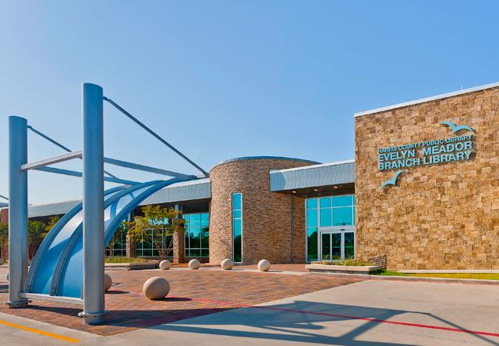
Evelyn Meador Library
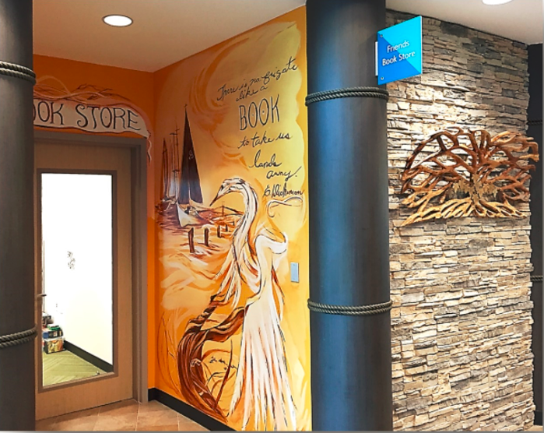
Friends Bookstore
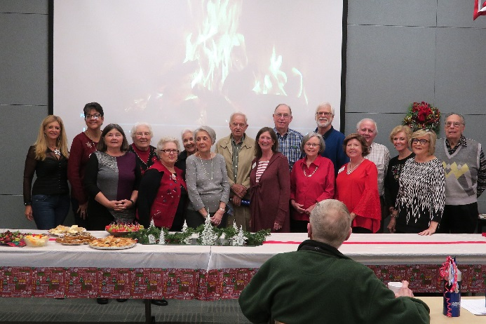
Friends of Evelyn Meador Board of Directors
Save The Dates!
4th Annual Library Beautification Event
(Outdoor facilities only)
When: Saturday, March 23, 2019 from 10:30 am-12:00 pm
Where: Evelyn Meador Library

2019 Friends Annual Meeting
When: Tuesday, April 23, 2019 at 7:00 p.m.
Refreshments will be served at 6:30 p.m.
Where: Evelyn Meador Library, Wallach Community Room
(Speaker to be announced)
Check our web site, friendsofevelynmeador.org for updates!
---------------------------------------------------------Cut here---------------------------------------------------------------

2019 Friends of Evelyn Meador Library Membership Application Form
Mail with payment to: Friends of Evelyn Meador Library
PO Box 684, Seabrook, TX 77586
___ Family $10.00
___ Patron $50.00
___ Sustaining $100.00

Name: __________________________________________________________________________________
Address: _______________________________________________________________________________
Phone: _________________________________________________________________________________
Email: __________________________________________________________________________________

