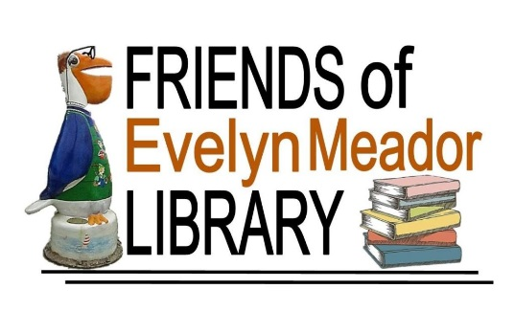
Web site: friendsofevelynmeador.org
E-mail address: info@friendsofevelynmeador.org
Friends of Evelyn Meador Library Annual Newsletter
January 2021 Edition
Dear Friends,
Once again, it’s membership renewal time for the Friends of the Evelyn Meador Library! If you have already renewed, please accept our sincere thanks for your support. If you would like to renew or become a member, please return the enclosed membership form found at the end of this newsletter.
We hope you have been enjoying Evelyn Meador Library and Friends Bookstore! Here are just a few of the programs and events that the Friends supported in 2020:
- March - Konradi Memorial Herb Garden
- June - Summer Reading Program
- June – August Evelyn Meador Library’s 31st Birthday Celebration
- November Edible Tree Forest
Despite the pandemic, the library still offered the following 951 programs:
Adults: 375
Teens: 115
Children: 123
ESL: 338

Many of the programs were virtual. The library offered curbside service starting in May even when the library was closed to the public. There were 661 nourishing kid friendly meals served (to go) over the summer as well.
Evelyn Meador Library continues to be a cornerstone of our community. The program offerings are designed to benefit and enrich the communities that we serve. Plans for 2021 are equally as exciting!
2020 Spotlight – Evelyn Meador Community Garden!
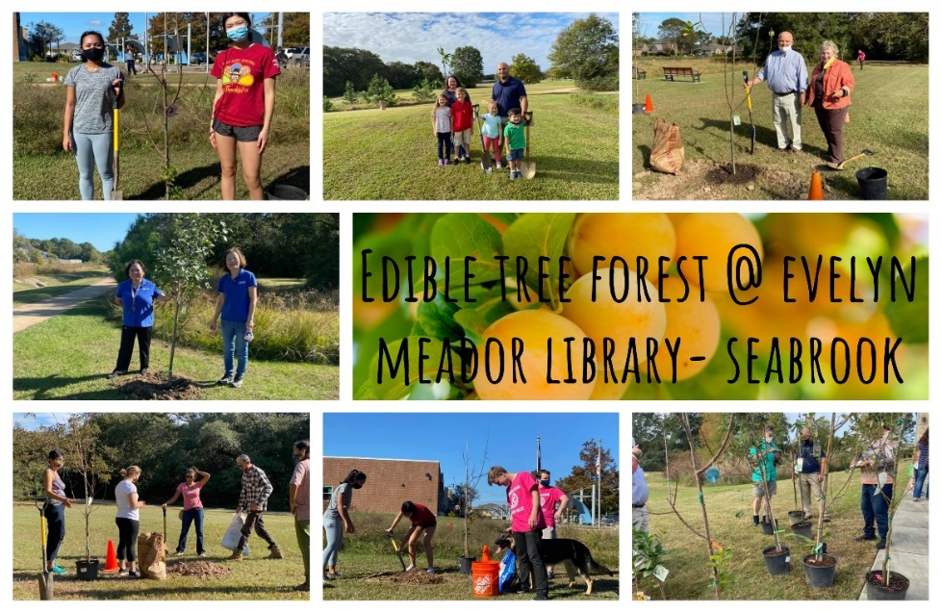
If you haven't heard, there's a community garden coming to Evelyn Meador Library!! Ground breaking began Sunday, February 9, 2020 and will continue throughout 2021.
Here are the planned phases:
- Phase 1 – Memorial herb garden- completed June 2020
- Phase 2 – Outdoor Learning Space and vegetable gardens – starts February 2021
- Phase 3 – Food forest (trees with edible fruit)- completed November 2020
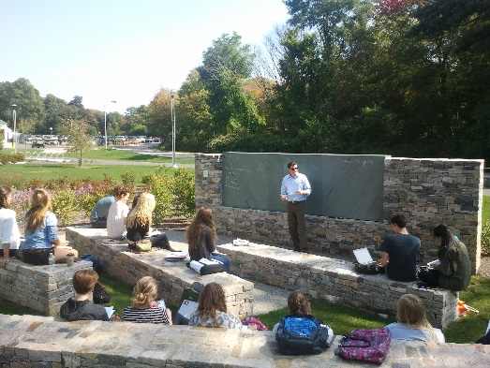
Rendering of the planned Outdoor Learning Space
We'd love for you to join us in this sustainable community project! Look for future volunteer opportunities! Here are several planned events:
- Ground Breaking Day for the Outdoor Learning Space – February 2021
- Annual Beautification Project – April 10, 2021
- Earth Day – April 22, 2021
- Celebrate Evelyn Meador Library’s 32nd Birthday on June 28, 2021. Harris County Public Library celebrates its 100 Year Anniversary in 2021!
The Friends depend largely on membership dues, book sales and financial donations. Our fundraising efforts help support library programs and offerings that enhance the community in which we serve. As a 501(c)(3) organization, all donations are tax deductible! Here are a couple of convenient options to consider:

- Kroger Community Rewards Program - if you’re not already linked to an organization, please consider taking part in this program. Kroger will contribute to participating organizations based on their percentage of spending as it relates to the total spending of all participating Kroger Community Reward organizations. Here’s how to set it up:
  - Go to www.kroger.com/signin?redirectUrl=/account/communityrewards/enroll
  - Sign in with your Kroger account information or create a new account. A digital account is required to activate this feature.
  - Find your Organization – search for “FRIENDS OF THE EVELYN MEADOR LIBRARY # 80603”
  - Select and enroll. It’s that simple! Your enrollment in Community Rewards needs to be renewed each year.
  - REMEMBER, purchases will not count towards rewards until after you have registered your Kroger Plus card and linked it to the Friends.

- Amazon Smiles - register with Amazon Smile and every time you make an eligible purchase, Amazon will donate 0.5% to the Friends of Evelyn Meador Library! It's easy to sign up, doesn't cost you anything, and will directly benefit our organization. Here’s how to set it up:
- Go to www.smile.amazon.com
- Sign in using your existing Amazon account or register for an account.
- Under “Pick your own charitable organization” search for “Friends of the Evelyn M Meador Community Library”.
- Click “Select” and you’re done! You should get an email confirming your Amazon Smile registration.

- Network for Good - We’ve teamed up with Network for Good to bring you an easy, no fuss donation experience! It’s really simple…just click on the “Donate Now” link at the top of our Home Page; it will take you to a secure site that will walk you through the donation process. A receipt will be sent to your registered email address.
Save The Dates!
5th Annual Library Beautification Event
(Outdoor facilities only)
When: Saturday, April 10, 2021 from 10:00 am-12:00 pm
Where: Evelyn Meador Library
2021 Friends Annual Meeting
When: Tuesday, April 27, 2021 at 7:00 p.m.
Where: Virtual Meeting
Guest Speakers: Mayor Thom Kolupski and City Manager Gayle Cook will give us an update on the Highway 146 Expansion Project!
Check friendsofevelynmeador.org for updates and reminders!
---------------------------------------------------------Cut here---------------------------------------------------------------
2021 Friends of Evelyn Meador Library Membership Application Form
Clip completed form and mail with payment to:
Friends of Evelyn Meador Library
PO Box 684, Seabrook, TX 77586
___ Family $10.00
___ Patron $50.00
___ Sustaining $100.00

Name: __________________________________________________________________________________
Address: _______________________________________________________________________________
Phone: _________________________________________________________________________________
Email: __________________________________________________________________________________

